**DAY 3 of Network Analysis**

1. **VRP with added routes and conditions**

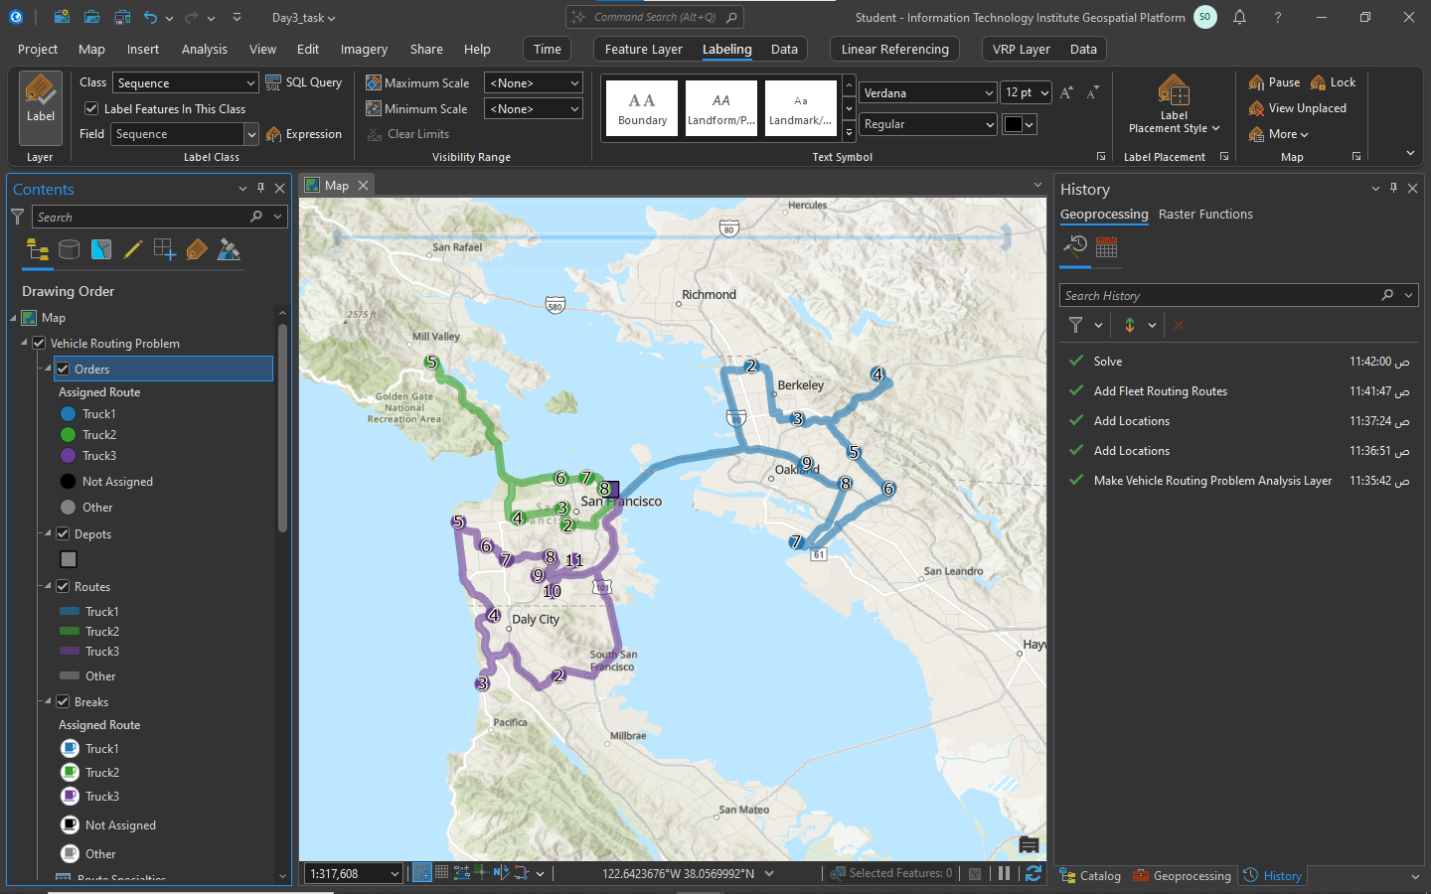

1. 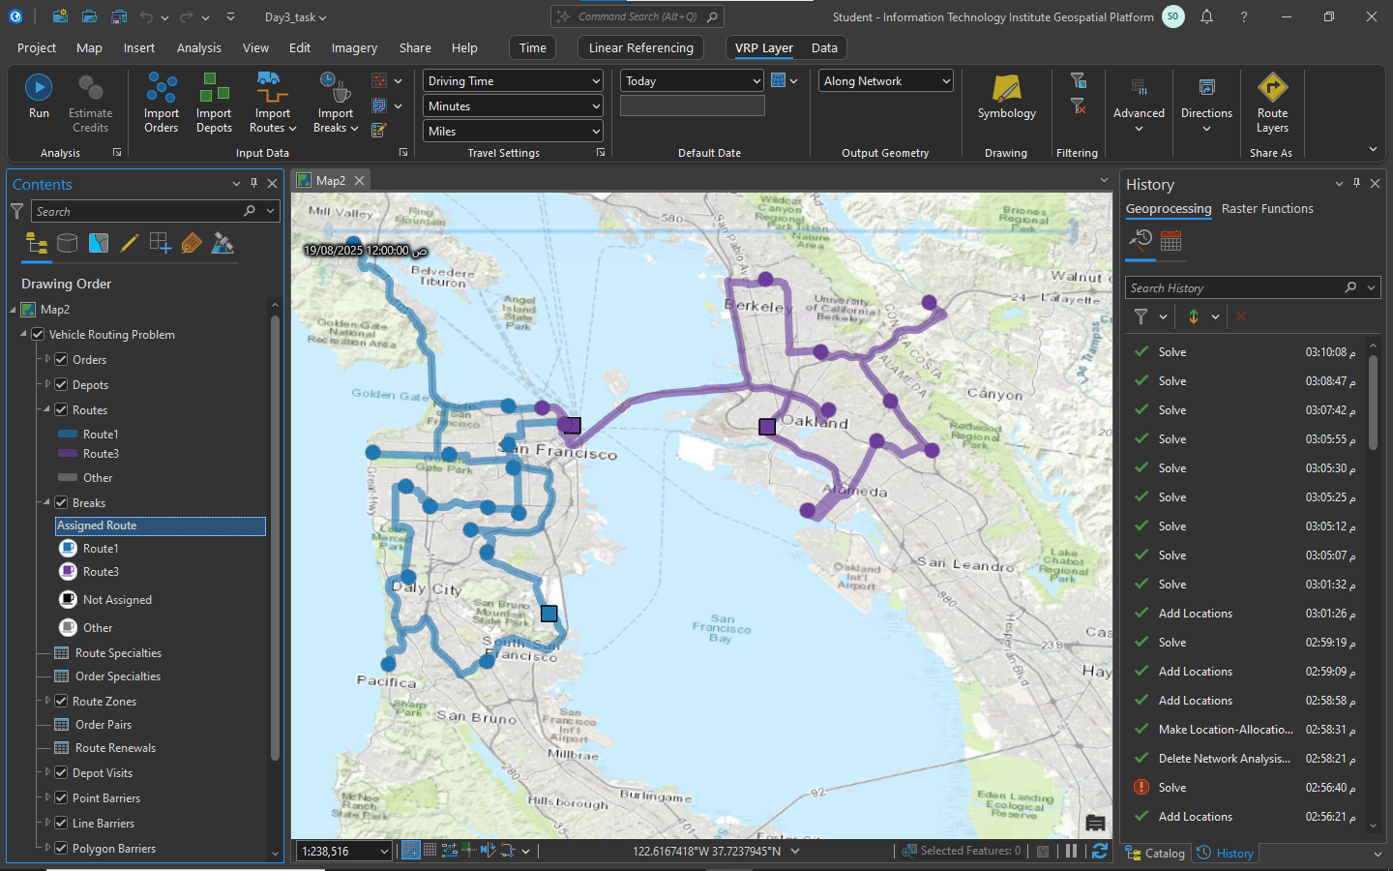**VRP Renewal**
2. **Breaks**

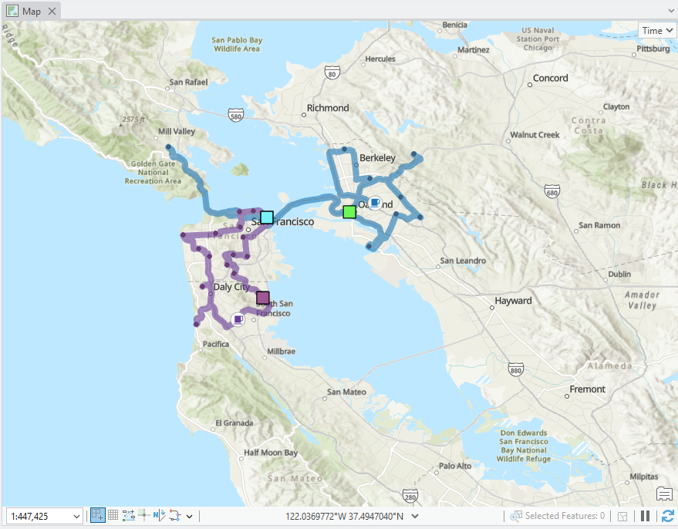

1. 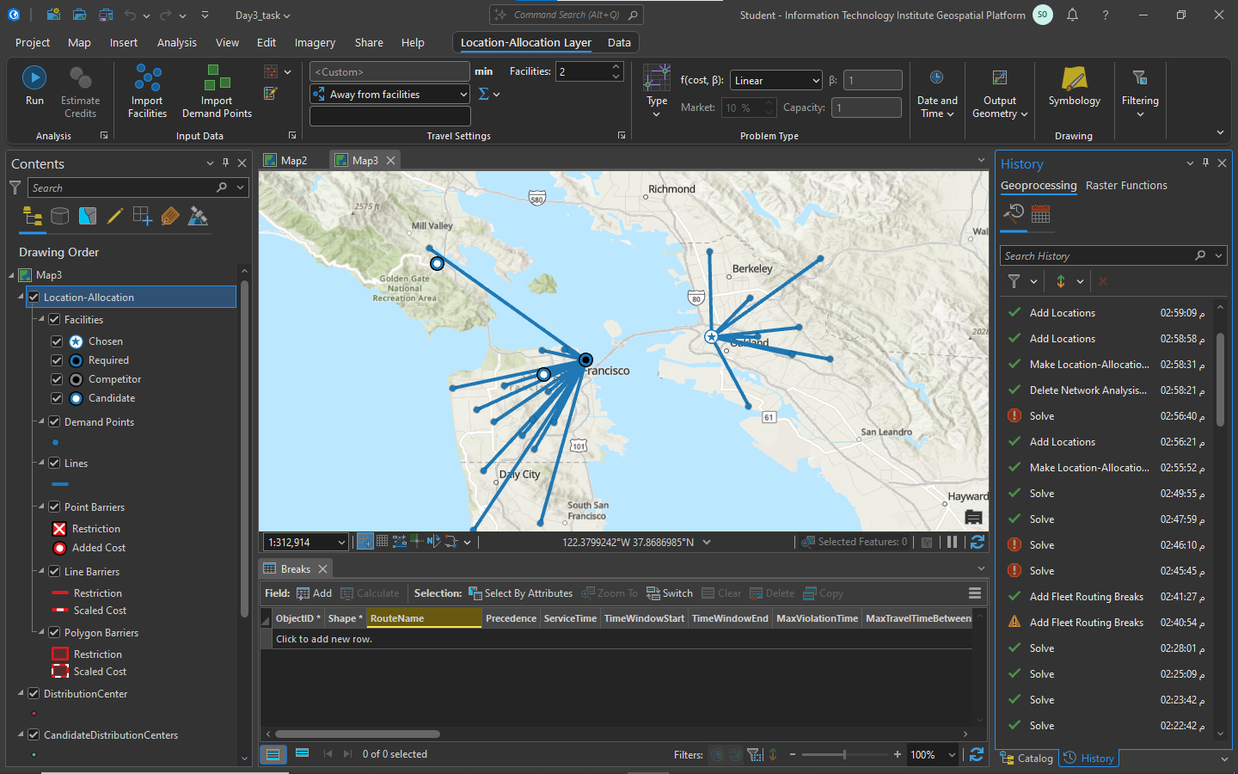**Location Allocation**